Assignment-2

Data Communication & Computer Network-Laboratory

**Student’s Roll No:** **RDOC09A55**

**Student’s Reg No: 12114762**

**Student’s Section: DOC09**

**Student’s Name: Pranav mishra**

Question: Create a static routing interface of two routers for 4 end devices?

Answer:

**Step 1:**

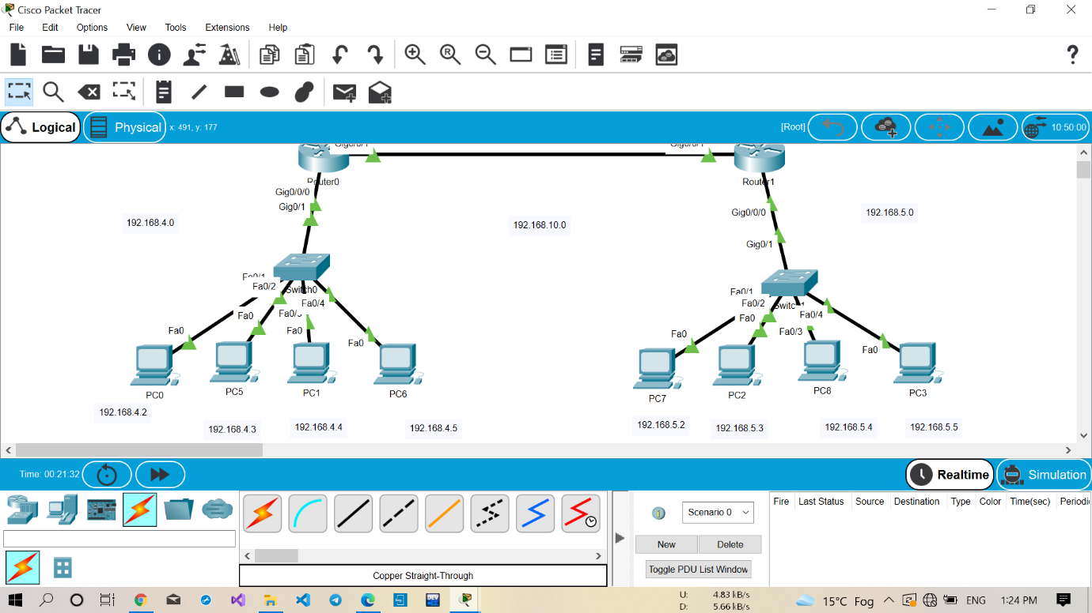

**Step 2:**

